
A

ALUMINIUM COLOURS AND PRICING

The pricing field in the quotation setup of QuoCut Professional corresponds to the price book issued by Capral. You will need to refer to the Price Book for colours that fall into each of the categories listed below.

MILL, PC_GRP_1 (Standard Powder Coat Finish), PC_GRP_2, PC_GRP_3, PC_GRP_4, PC_GRP3D and ANODISED ( Various Anodised pricings and codes)

Note: The question mark beside the colour box gives more information as to selections for pricing. The L will show selections available for the group chosen in the first colour field.

Pricing field and colour description field
The quote and item screens shown below indicate the options available for colour. Whatever option is chosen in the colour field the description of the selection will default in the next drop down field.

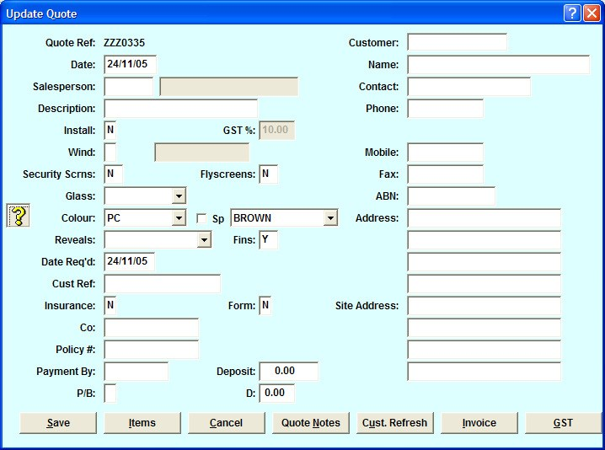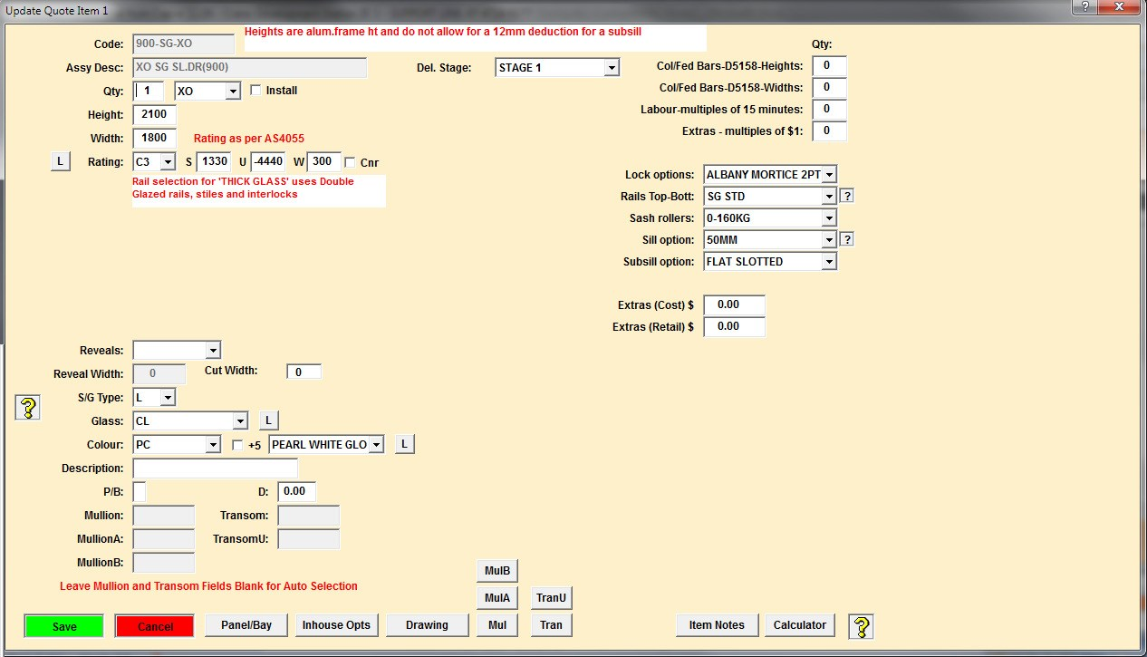

At this point the user may select from the drop down list a colour description applicable to the quoted item. The selections chosen on the quote screen will default to the item screens, but may be updated at any time by individual item.

Pricing and description options
To ensure items are calculated accurately you will need to select the correct pricing option for powder coat or anodizing. The pricing option is selected from the first colour drop down box and then the applicable colours will display in the next field.

Customised special powder coat finishes
The user may set up special powder coat options based on a square metre or lineal metre basis. A special colour is selected when extrusions are purchased as mill finish and a third party powder coats the metal.

Note: The selection of square metre or lineal metre is performed in the menu – System Configuration | System Options.

A

ALUMINIUM COLOURS AND PRICING

3.1 Setting up a special colour
Select the following menu option -

Setup | Aluminium Colours (Pricing)

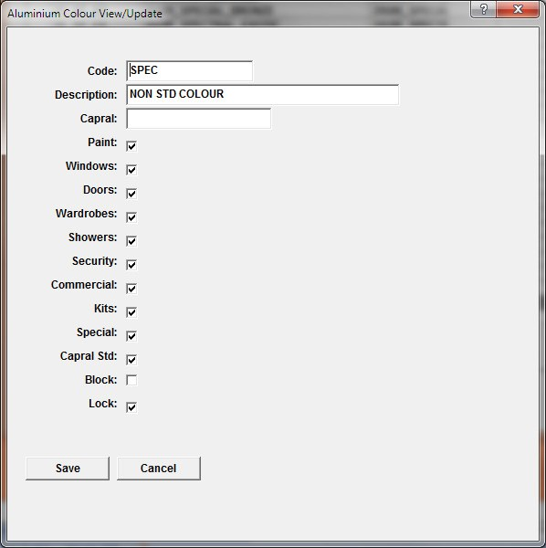
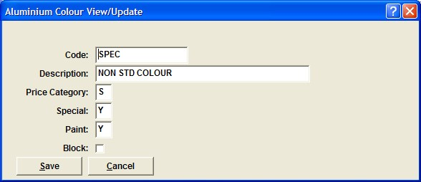
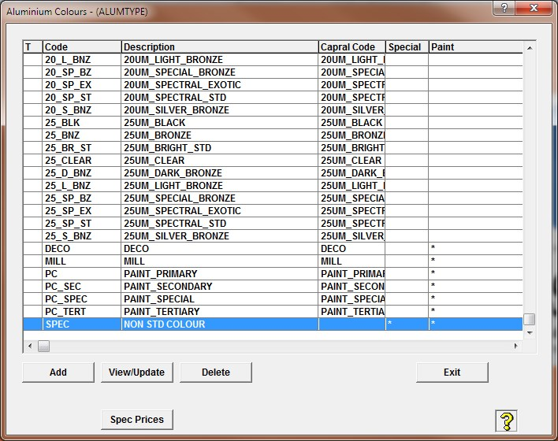

- Use the Add button to add another colour; the code should be meaningful
- Select the Special, Paint and Capral Std fields as well as all other fields you would like this colour to be applied to (see above).
- DO NOT select Block or the colour will not be available to price.
- Save to go back to the Aluminium Colours screen.
- Use the Spec Prices button to record the $ per sq / lineal mt.

Aluminium Colour Descriptions
The user may modify product availability to suit individual requirements. The initial defaults are based on Capral’s nominated colours per product.

Modifying product availability
- Select the menu option – Setup | Aluminium Colour Descriptions
- Select the View/Modify icon
- Untick ‘Exclude’

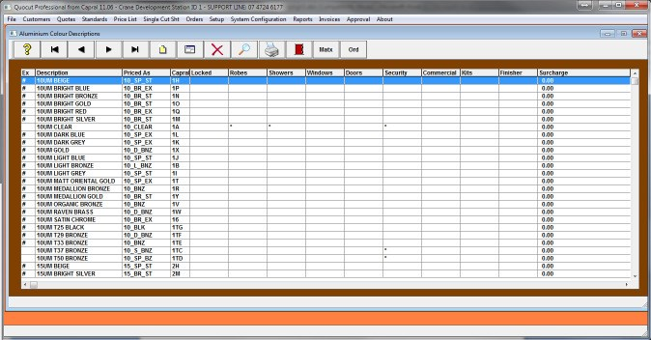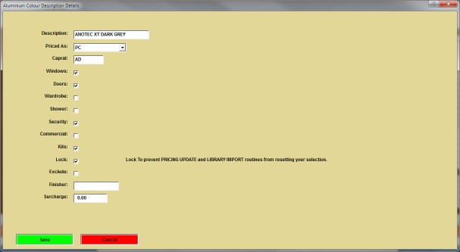

- Select the product required and then select lock to ensure the selection will not be updated with any upgrades to the program.

QuoCut Professional from Capral – 30/09/15
QuoCut Support Line: 07 4721 0175
- 2 -

